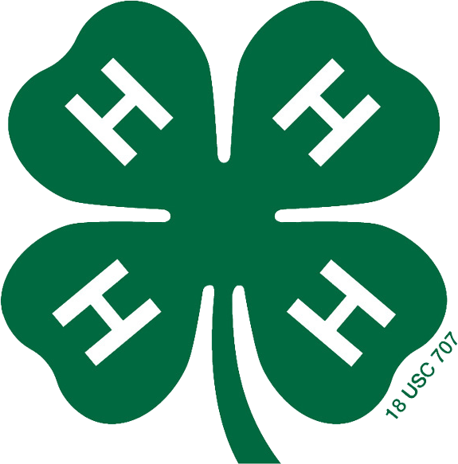
Be In The Know
Www.travis4h.com
http://travis4h.blogspot.com/
https://www.facebook.com/TravisCounty4H

Be In The Know
Www.texas4-h.tamu.edu
http://d104-h.tamu.edu/
http://www.facebook.com/District.10.4H
Texas 4-H Standard Newsletter

Tune Into the 4-H Network & The Multitude of Opportunities

County Opportunities
- Club Officer Positions
- County Council Officer Positions (possible District and even State)
- Various committees – varies relating to clubs and county
- Recordbooks
- Community Service - One Day and many others
- Workshops/Project Days, Science of AG Events – advertised throughout the year
- Award Opportunities
- Scholarships

District 10 & County Events
- District 10 Council
- Food Show/Nutrition Quiz Bowl – November
- Food Challenge – November/December
- Dairy Judging – February
- Horse Judging – February
- Consumer Judging – February
- Photography – February – April
- Meats Judging – April
- Wool/Mohair judging – April
- Soil Judging, Entomology ID, Range Eval, Range and Pasture ID - April
- Leaders 4 Life - April
- Roundup (Educational presentations, public speaking, share-the-fun) – April/May
- Fashion Show/Fashion Story Board/Textile Show – April/May
- Quiz Bowl – Beef and Horse - April
- Smallbore Riffle Contest – April
- Livestock Judging – April
- Horse Show – June
- Leadership Lab - June
- Recordbook Judging – July (Record books due to county office in June)
- Junior Leader Rally - July
- District 10 4-H Conference – August (formerly Mega Meeting)

***Most if not all district events are qualifying events for State 4-HRoundup***

State 4-H Events

- State 4-H Roundup - June - Other contests in addition to traditional contests:
  - Recipe Rally, 4-H Has Talent, SET Poster Contest, Wildlife, Vet Science Skill-a-thon, Healthy Lifestyles, Poultry Invitational, Swine Skill-A-Thon, Swine Quiz Bowl, Theme & Logo Contest, Quilt Challenge, 4K, Invitational Livestock Judging
- Texas Congress ( even years – 15 year olds) – July
- AG Products ID – Major Livestock Shows and State Roundup
- MASH Camp - June
- Mission Possible - Camp and Mentor Opportunities - July
- Golf Challenge - Summer
- Outdoor Challenge – June/July
- Prime Time ( 9-13 year olds) – July
- State Horse Show – July
- Tech Team – Applications due in early September
- Clothing Advisory Board, Healthy Lifestyles Board
- Various camping opportunities at the Texas 4-H Conference Center
  - http://texas4hcenter.tamu.edu/
• Various shooting sports events and leadership opportunities
- Various Opportunities at Major Livestock Show (public speaking, skill- a- thons, judging contests)
- Scholarships
- Texas 4-H Science and Robotics
- Recordbooks – Leadership Conference
- Texas 4-H Dog Show
- Rabbit Extravaganza

National Events

- National Congress
- National Conference
- Citizenship Washington Focus
- Wonders of Washington
- 4-H Day at the Capitol

Extra Events & Opportunities
***Only naming a few***
- Bee Keeping Essay Contest
- Capitol Photography Contest
- Livestock Ambassador Program, Equine Ambassadors Program
- Volunteer Conference
- Roundup Theme and Logo Contest
- County Shows that offer “OPEN” opportunities; Brazos Valley Fair, Burnet County Fair, etc.
- Military Program Opportunities
- 4-H Night at Sporting Events (Rangers, Texas Stars, Spurs)

